Kia ora! Participant reflects on PEP 2018 and Aotearoa/New Zealand hospitality

By Daniela Hoelblinger, Austria

I chose to apply for the PEP in New Zealand for many reasons and was one of the very lucky six social workers to actually participate. It wasn´t my first visit to this beautiful country with its wonderful inhabitants and there´s just something about New Zealand that always makes me want to go back, to learn more, to see more, to look deeper and to make new experiences.

During my stays I came across this Maori proverb a couple of times and would like to share it:
He aha te mea nui o te ao? he tāngata, he tāngata, he tāngata
What is the most important thing in the world? It is people, it is people, it is people.

It sits on my desk and not only makes me fondly remember the time I spent in New Zealand and the extraordinary people I came across, but also defines the perspective we have as social workers. When supporting a person in need we ask: Who is there to help? To whom are you connected?
Never before the program did I have the pleasure to meet, talk to, learn from and laugh with so many social workers from different backgrounds and different countries, and for making this opportunity happen I´m very grateful to CIF.

After a great weekend at the beginning of the program in Auckland with all of us together at the CIF president´s house where we were warmly hosted and spoiled with delicious homemade New Zealand treats, we spent three days at the Unitec. The lectures provided us with insight into the Treaty of Waitangi, New Zealand history, Māori culture, values and customs, how to introduce and acknowledge each other in Māori and memorised a waiata (song) and karakia (prayers). A major part of showing hospitality is the sharing of food after a welcome, something that we did often. The next day we visited Oranga Tamariki (ministry for children), where social workers from different teams told us about their work. We also experienced the much talked about variable New Zealand weather, with heavy rain that poured down on us nearly horizontally, and as the day progressed so did the weather – to sunshine.
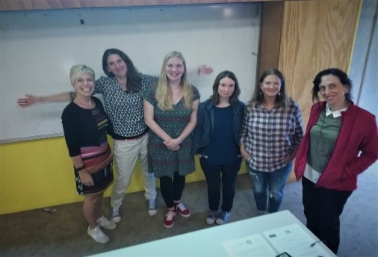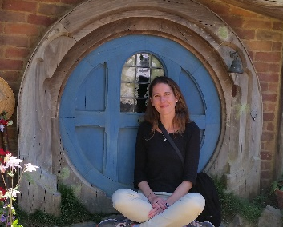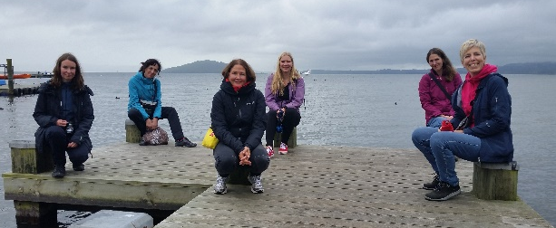
In Hobbiton and Rotorua
Hetty (Netherlands), me (Austria), Anu (Finland),
Claudia (Germany), Petra (Sweden), Maria (Spain)

On Friday we set off on a self-organised short trip around the North Island where we tried to fit in as many interesting sights as possible and got to know each other even better.

Energised after our weekend getaway we started our second week with a visit to Auckland Museum and Auckland City Mission, accompanied by CIF member, Joy. The following day was spent at Auckland City Hospital, one of the most interesting visits as we got to spend 1:1 time with a social worker and had client contact.

The next part of our programme was held in New Plymouth, the major city in Taranaki region, to spend the next part of the program in a different, more rural part of New Zealand. Everybody was excited to go, the only setback was that we had to say goodbye to one of our friends as she withdrew from the program for personal reasons and went home. So, a more than six hour bus ride later, the remaining five of us were warmly greeted by our new host families. New Plymouth is an amazing city of roughly 60,000 people, with beautiful gardens and a perfectly coned volcano in the backyard. A very busy schedule lay ahead of us, our time was filled with visits to a lot of different agencies and organisations in and around the city. Yet once more our hosts went out of their way to make us feel welcome and part of their family. For our visits my host mum even lent us her car to make it more convenient to go around. All the agencies and organisations that opened their doors treated us so kindly and told us about the important work they do.

On a personal point of view there seemed to be a lot of different social organisations and community services in Taranaki for such a largely rural region, necessarily many of them are doing a lot of outreach work. Some of the social workers we talked to told us about the lack of government funding, the ways they have to come up with funding by themselves, and that they never quite know if they can still provide their services in a year’s time. I have utmost respect for all those who work, motivated and tireless under such circumstances. The cooperation with the communities plays a very important part and we heard about possible ways social organisations are trying to get the community involved. Also, quite different from my country is the positive cooperation with the police in many different social areas. Police officers working alongside social workers are not an exception as we saw for ourselves. We should definitely learn from this approach.

A highlight from our time in New Plymouth was our live on-air radio talk on the community station Access Radio. Our group along with Rachel and Sarah from CIF New Zealand, although we were quite nervous all went smoothly and we had a lot of fun. We introduced CIF, talked about our home countries, our work and how we as social workers revive ourselves. Local musician Wesley joined us in the studio with his guitar and listening to his songs gave everyone goose bumps. After one and a half weeks of lasting memories we heavy hearts we had to say goodbye returning to Auckland.

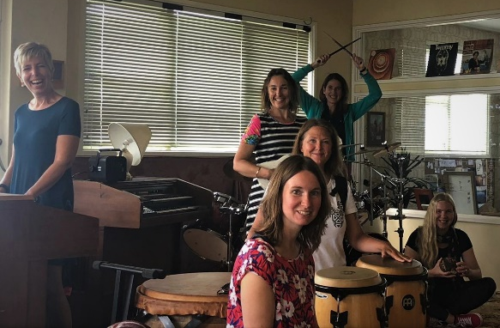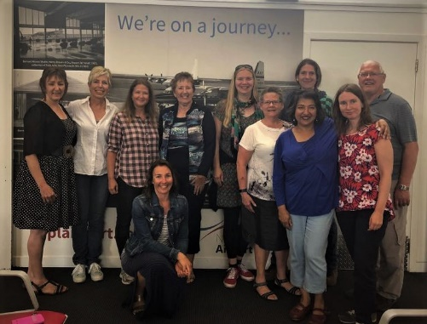

We spent rest of the weekend with our host families; together with another participant I stayed with Sue and her beautiful family. After she picked us up from the airport we went for a stroll to Auckland´s West Coast beaches and her equally hospitable husband Murray took us on a fishing trip the next day, I even managed to catch a fish which he cooked for us back at their home.

Our last week was spent on our individual placements. I had the chance to spend one day with a school social worker, two days at the Child and Youth Mental Health Service Marinoto where I got an insight into the Choice and Partnership approach, and one day at Oranga Tamariki Takapuna, which was among my most memorable visits. During this placement I was able to look into the assessment and practice tools they use, talk with a social worker responsible for Family Group Conferences and to another one from the Youth Justice Team, and even accompanied a social worker to a home visit to follow up on a report of concern. Those days flew by and I always stayed longer than intended, as I was never short on questions to ask and patient staff members willingly clarified them.

The end of that intense week sadly also meant the end of the program. After the final evaluation and farewell party, our group had to say goodbye to each other and to our host families in Auckland who cared for us so much. As for us participants we promised to visit each other and to come back together again, the planning for a reunion is already underway as I´m writing this reflection. Looking back now nearly six months after the exchange program I was so fortunate to participate in, it still fills me with joy and gratitude. I got so much more than I could have ever wished and asked for. With all my heart I thank the members of CIF Aotearoa/New Zealand who made everything possible, my two amazing host families and all the other kind people who crossed my path and I was so lucky to meet.

